Sardine The Cat: Chapter 1

MaxScoottGames

GDD Written by: Max Scott, Griffy, Milk And Dice

Not for sale!

Overview
Theme / Setting / Genre
Core Gameplay Mechanics Brief
Targeted platforms
Monetization model (Brief/Document)
Project Scope
Influences (Brief)
The Elevator Pitch
Project Description (Brief)
Project Description (Detailed)
What sets this project apart?
Core Gameplay Mechanics (Detailed)
Story and Gameplay
Story (Brief)
Story (Detailed)
Gameplay (Brief)
Gameplay (Detailed)
Assets Needed
2D
3D
Sound
Code
Animation
Schedule
<Object #1>
<Object #2>
<Object #3>
<Object #4>

Overview

Theme / Setting / Genre
○ The events of Sardine The Cat take place in an imaginary world full of anthropomorphic animals. The protagonist is a cat named Sardine, who needs to save his town. Will he succeed? What will he find during the adventure? And what secrets will this world reveal?

○ The setting is a post-apocalyptic world. As the nuclear war wiped the civilization out, the survivors dispersed into to multiple shelters, dying one by one and turning into ghosts. The evolutionary lead was taken by animals, who started building a civilization of their own. After a long geopolitical struggle, only 3 city-states were left: Avis, Felicis and Velesgrad.

○ Action RPG, drama, ageplay, comedy, psychological horror, foot fetish, adventure, fantasy.

Core Gameplay Mechanics Brief
  - Melee Attacks, Dodging and Magic
  - Quests, chests, artifacts, mythology stories for Extras
  - Crafting system, cooking, inventory, shopping
  - Simple enemies, Bosses, Plot bosses

Targeted platforms
  - PC: Windows, Mac
  - Console: Xbox, PS, Nintendo Switch
  - Mobile: Android, IOS

Monetization model (Brief/Document)
  - <Monetization Type> /Premium, Paid Alpha/Beta/Final, Ad Driven, Micro-transactions, Subscription, etc./
  - <Link to Monetization Document>
  - /How do you plan to monetize the game?/

Project Scope
  - Game Time Scale
    - 3$ /How much will it cost?/
    - 3-5 hours /How long will it take to make this game?/
  - Team Size
    - Core Team
      - Max Scott
        - The lead dev, programmer, designer and writer
        - full time <percentage from the getting money per month>
      - Jacob (Milk and Dice)
        - The writer and a right hand
        - full time/part time <>
      - AleksShar
        - The programmer
        - Part time <>
    - <Marketing Team>
      - <Team Member Name>
        - /What does he/she do?/
        - <Cost to employ them full time or part time>
        - <etc.>
      - /List as many marketing team members as you need to/
  - Aseprite, Gamemaker (1500 rubles if we are exporting to a console)
  - 1500 rub for GM + 10000 rub for Steam Creator + +-25000 rub for international bank

Influences (Brief)
  - Scott Cawthon’s pre-Fnaf works
    - Games and Cartoons (Chipper and sons, Pilligrim’s progress, The desolate hope, etc.)
    - I admire Scott and his work, especially the before FNAF era. So I wanted to show it through my game. There will be references to characters portaited by my characters and lore
  - Deltarune
    - Games
    - Just like the way it was developed on GML and the music.

The Elevator Pitch
<A one sentence pitch for your game>
/Pretend that you are pitching your game to an executive in an elevator. You have less than 60 seconds./

Project Description (Brief)
Sardine the Cat is an adventurous game with the fantastic world full of anthropomorphic animals, who replaced humans after a global-scale nuclear war. It is a story about bravery, friendship and hope. The gameplay includes JRPG fighting style like in the Legend of Zelda, you can cook meals, craft things, interact with NPC’s and do the quests, Open Chests for the Artifacts and learn about the mythology of the world. Fight bosses and find out about the lore.

Project Description (Detailed)
Sardine the Cat is an Action RPG about a brave warrior cat named Sardine, who is set on saving his city and the loved ones. The setting is a post-apocalyptic world inhabited by anthropomorphic animals, who replaced humans after centuries of evolution.

The journey is kicked off by a vampire named Kageki. He gives Sardine help with encountering Cave Guardians (bosses). Defeating them is key to obtaining artifacts and saving Felisis.

The first quest takes place in a beautiful swamp, divided into three small sections for Slimes, Frogs, and Insects. Each is ruled by one of three nymph sisters, who will be final bosses. The swamp is also inhabited by robots, who give insights into the lore.

The second quest takes place in a cave full of worms. (W.I.P.)

The third quest takes place at an abandoned shelter, where people hid from the nuclear war. There Sardine meets several characters: Marianne, Irina and Phil. Irina and Phil, just like the nymphs, will have their small ghost minions which will help attack Sardine. Marianne, on the other hand, will be friendly, and will play a small but significant part in the lore.

The Final Boss will be a ghost named Phoebe. Her fight would stretch over multiple phases and forms. After the fight, she will tell Sardine the crucial information about the world; we will also meet Kageki again, who, just like Phoebe, isn’t a villain. The two were just testing Sardine if he could fight the real evil.

Throughout the game we will occasionally meet Edgar – the henchman of a main villain, who is constantly following Sardine. He is more of an easter egg in the background.

The gameplay will be simple, yet diverse and exciting. It will contain elements of classic RPGs like "the Legend of Zelda", which include: fighting, levelling system, shopping, and exploring. The NPC dialogue will also be diverse.

This game will incentivize multiple playthroughs, with extras to be unlocked, artifacts to be obtained and multiple endings to be seen.

What sets this project apart?
  - A lore full of drama and adventures
  - A unique pixel-art style
  - A lot of References to Scott Cawthon’s work
  - A lot of references to Greek Mythology
  - A room full of the game creators for the gags and cameo

Core Gameplay Mechanics (Detailed)
  - Melee Fighting
    - <Details> A melee figthing popular in RPG games. With dodges and attacks to strike an enemy. The boss fighting is W.I.P, but the inspiration take the Cult of Lamb.
    - <How it works> Basically like in the LoZ but more colorful, epic and exciting.
  - Magic Fighting (W.I.P)
    - <Details> For inspiration take the Hades style
    - <How it works> /Describe in 2 Paragraphs or less/
  - Crafting & cooking (?)
    - <Details> /Describe in 2 Paragraphs or less/
    - <How it works> /Describe in 2 Paragraphs or less/
  - Exploration (?)
    - <Details> /Describe in 2 Paragraphs or less/
    - <How it works> /Describe in 2 Paragraphs or less/

Story and Gameplay

Story (Brief)
○ The Story is about bravery, friendship and hope. Sardine will uncover the secrets of the world, get acquainted with lots of interesting characters, and fight monsters getting in the way.

Story (Detailed)
○ The story starts off pretty grim: Sardine's town is under attack, which seems hopeless to resist. Not knowing what to do, he escapes into the cave with the town's artifact. As he wanders, lost and with no destination in mind, he meets a vampire named Kageki, who sends him to explore the cave. There, he will meet a lot of characters (aforementioned), and learn about life, hope, and the big world outside of the town.

Gameplay (Brief)
The main pillar of the gameplay is melee and magic combat. Various types of equipment and artifacts are scattered around the world. The player can also interact with NPCs and participate in minigames.

Gameplay (Detailed)
The gameplay is split into 3 distinct activities:

Combat: The game offers a melee + magic combat system.

Upgrading: The player can perfect their build by:
• Buying, finding, crafting and looting new equipment;
• Cooking various food and potions;
• Levelling up and getting passive buffs.

World exploration: the player can interact with various NPCs, participate in side quests and play minigames.

Assets Needed

2D
  - Textures
    - Pixel art texture drawn by hand
    - Concept Art for characters
  - Character List
    - Main Characters
      - Sardine – the player
      - Kageki – the main villain
      - Phoebe – the main villain
      - Edgar – the minion, background
    - Swamp
      - Nymphs (W.I.P) - bosses
      - Minor Enemies
        - Slimes (W.I.P)
          - Original
          - Bomb
          - Water
        - Frogs (W.I.P)
        - Insects (W.I.P)
      - Non-threatening NPC’s
        - Braden
        - Barnaby
        - Kevin
    - Worms (W.I.P)
    - Shelter
      - Bosses
        - Irina
        - Phil
        - Phoebe (just an honorable mention)
      - Minor Enemies (W.I.P)
      - Non-threatening NPC’s
        - Marianne
        - Shopkeeper (W.I.P)
  - Environmental Art Lists (W.I.P)
    - Cave
    - Swamp
    - Worm
    - Shelter

Sound (W.I.P)
  - Sound List (Ambient)
    - Outside
      - Level 1
      - Level 2
      - Level 3
      - etc.
    - Inside
      - Level 1
      - Level 2
      - Level 3
      - etc.
  - Sound List (Player)
    - Character Movement Sound List
      - Example 1
      - Example 2
      - etc.
    - Character Hit / Collision Sound list
      - Example 1
      - Example 2
      - etc.
    - Character on Injured / Death sound list
      - Example 1
      - Example 2
      - etc.

Code
  - Character Scripts (Player Pawn/Player Controller)
  - 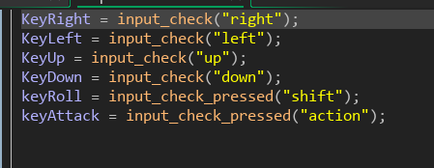
  - 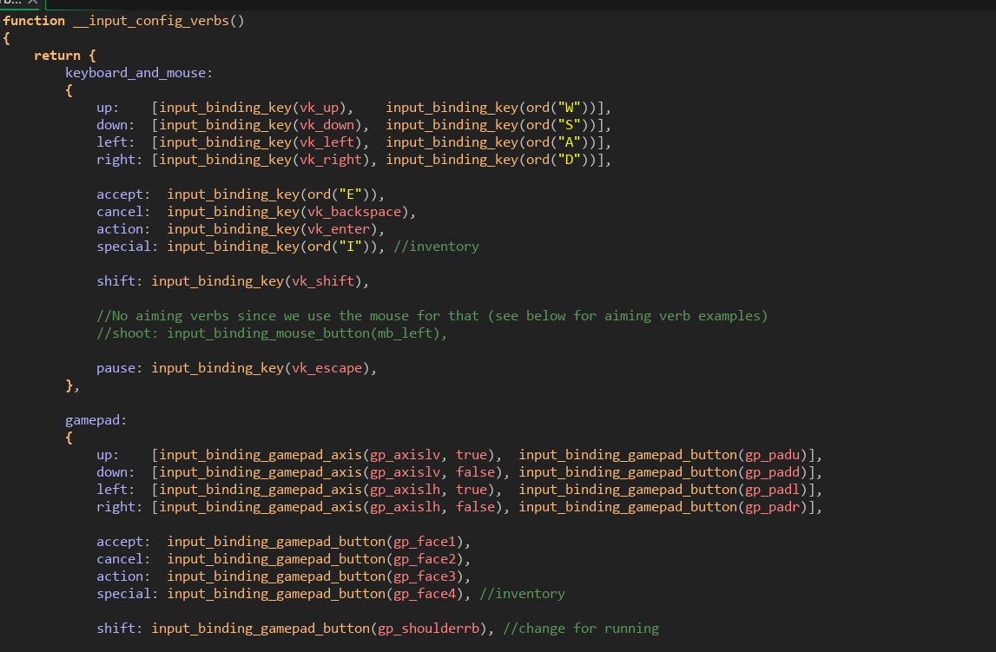
  - Ambient Scripts (Runs in the background) (W.I.P)
    - Example
  - NPC Scripts
    - All objects for the NPCs (Parent ones). For the code use Gamemaker to read
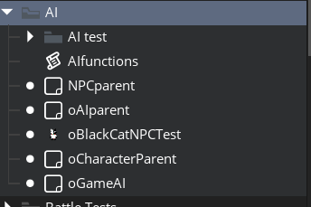
    - Slime
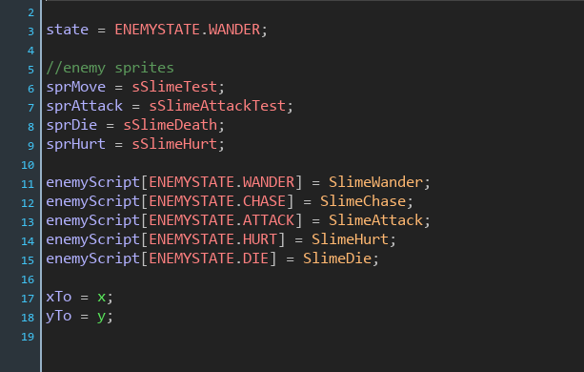

Animation (W.I.P)
  - Environment Animations
    - Example
    - etc.
  - Character Animations
    - Player
      - Example
      - etc.
    - NPC
      - Example
      - etc.

Schedule

<Object #1>
  - Time Scale
    - Milestone 1
    - Milestone 2
    - Etc.

<Object #2>
  - Time Scale
    - Milestone 1
    - Milestone 2
    - Etc.

<Object #3>
  - Time Scale
    - Milestone 1
    - Milestone 2
    - Etc.

<Object #4>
  - Time Scale
    - Milestone 1
    - Milestone 2
    - Etc.

GDD Template Written by: Benjamin “HeadClot” Stanley

Special thanks to Alec Markarian
Otherwise this would not have happened

Reformatted by: Brandon Fedie

